IBM PROJECT REPORT

**HAZARDOUS AREA MONITORING FOR INDUSTRIAL PLANTS POWERED**

**BY**

**IoT**

**Domain: Internet of things.**

**Team ID: PNT2022TMID48761**

**College Name: NSN college of Engineering & Technology ,Karur**

### Department of Electronics and Communication Engineering

**DINESH S (920919106008)**

**KARTHIK V (920919106008)**

**SIVAKUMAR A (312819106013)**

**ARUNKUMAR M (312819106011)**

**MANOJ K (312819106042)**

**INDUSTRIAL MENTOR : BHARADWAJ**

**COLLEGE MENTOR : ANAND G**

**TABLE OF CONTENTS**

1. INTRODUCTION 3

a. Project Overview 3

b. Purpose 3

2. LITERATURE SURVEY 3

a. Existing Solutions 3

b. References 4

c. Problem Statement Definition 4

3. IDEATION & PROPOSED SOLUTION 5

a. Empathy Map Canvas 5

b. Ideation & Brainstorming 6

c. Proposed Solution 7

d. Problem Solution fit 9

4. REQUIREMENT ANALYSIS 9

a. Functional requirements 9

b. Non-Functional requirements 10

5. PROJECT DESIGN 11

a. Data Flow Diagrams 11

b. Solution & Technical Architecture 11

c. User Stories 12

6. PROJECT PLANNING & SCHEDULING 14

a. Sprint Planning & Estimation 14

b. Sprint Delivery Schedule 15

7. CODING & SOLUTION 16

8. TESTING 17

a. Test Cases 17

b. User Acceptance Testing 17

9. RESULTS 18

a. Performance Metrics 18

10. ADVANTAGES & DISADVANTAGES 19

11. CONCLUSION 20

12. FUTURE SCOPE 20

13. APPENDIX 21

a. Source code 21

b. Video demonstration links 22

# 1. INTRODUCTION

In some industrial plants, there are some areas which are to be monitored from time to time. Sometimes the conditions may become critical which may lead to loss of property and also human loss. Industrial accidents are as old as the industry itself and so are preventive measures. The Standards for Explosive Areas or Atmospheres have also evolved diversely worldwide, based on the local needs of the industries for the overall safe operation of the plants. Explosions and fire are two of the major constituents of these mishaps. Depending upon the environment, these can be termed 'Accidents' or fade away as simply the 'incidents' or 'Near Misses' in the safety officers' statistics. The first step to logically is to start defining and understanding some of the terms used in the whole scope of toss prevention in accidents due to explosion and fire.

## a. Project Overview

* Sending random Humidity and Temperature values will be sent to the IBM IoT platform.
* Sensors values can be viewed in the Web Application.
* Notifies the admin the random values cross the threshold value.

## b. Purpose

Through this, we can monitor the temperature and humidity parameters of a hazardous area in industrial plants. Every person working in those areas will be given a smart device for monitoring the random temperature and humidity values. We develop the web application for viewing the temperature and humidity data using Node-RED and if the temperature is higher than 60, then the admin of the industrial plant will receive the high temperature alert message or else admin will receive the temperature reset message through email using the Application programming interface (API) then the admin will take the necessary precautions if required.

# 2. LITERATURE SURVEY

## a. Existing Solutions

Proof of Concept [1] Software: Information-Centric Networking (ICN), low power lossy networks (LLNs) every piece of information has been collected through the cloud. No hardware specification

Research in [2] Microcontroller: Arduino Mega, WIFI Module (ESP8266). Service: Blynk, IoT Sensors: Smoke sensor (MQ-2), Temperature and Humidity. All the components are connected with IoT by using the Blynk application. The sensors are used for detecting smoke and temperature.

According to [3] Microcontroller: is an MPS480 and RF module, RFID, and Zigbee Sensors:

Temperature, smoke, and humidity sensors It can support thousands of nodes under a single

network. The transmission rate of this technology is low.

Research in [4] Microcontroller: Arduino Module: GSM Sensors: Temperature, smoke and flammable gas sensors, air quality sensor All levels of air pollution by detecting. Message send through GSM • No instances of action

## b. References

1. Frey, M., Gundogan, C., Kietzmann, P., Lenders, M., Petersen, H., Schmidt, T. C., … Wahlisch, M. (2019). Security for the Industrial IoT: The Case for Information-Centric Networking. 2019 IEEE 5th World Forum on Internet of Things (WF-IoT). doi:10.1109/wf-iot.2019.8767183.

1. IOT BASED INDUSTRIAL MONITORING SYSTEM Hemlata Yadav*1, Naomi Oyiza*2, Sarfaraz Hassan*3, Dr Suman Lata*4, K. Jaya Chitra*5 Volume:04/Issue:04/April-2022 Impact Factor- 6.752.

1. Sureshkumar A, S Muruganand, S Siddharthy, Manikandan N. “A Study on Computer Based Monitoring System for Hazardous Area Safety Measurement Using Virtual Instrumentation.” International Conference on Inter Disciplinary Research in Engineering and Technology (2015): 187- 191. Print.

1. February 2021International Journal of Safety and Security Engineering 11(1):123-127 DOI:10.18280/ijsse.110114

## c. Problem Statement Definition

To fulfil the modern-day human lifestyle and requirements many industrial plants play a major role. But with the exponential increase in growth of the industrial plants the safety and security of Workers and Engineers exponentially go down. This is due to a lack of Knowledge of hazards in the industrial plants among the employees. To overcome this bad situation industrial plants, need to develop some industrial safety regulations and maintain them. The industrial plants also need to be developed some infrastructure to monitor the hazards that happen in the industrial plants. And it helps the Engineers and plant managers to take the needful measures to avoid a bad situation. In case of any malfunction in plants, it will also affect the environment and livelihood around the plants.

**Problem statements:**

1. A Plant Manager needs to be informed of possible hazardous areas because they could pose a risk to the lives of the workers in the facility.

1. A technician needs to be informed whenever he is entering a hazardous area because it can lead to dangerous health complications to his/her or may cause disaster.

1. The Safety Inspector needs to easily examine whether the operations of the plant are hazardous or not. Because he needs to provide accurate reports to ensure safety.

# 3. IDEATION & PROPOSED SOLUTION

## a. Empathy Map Canvas

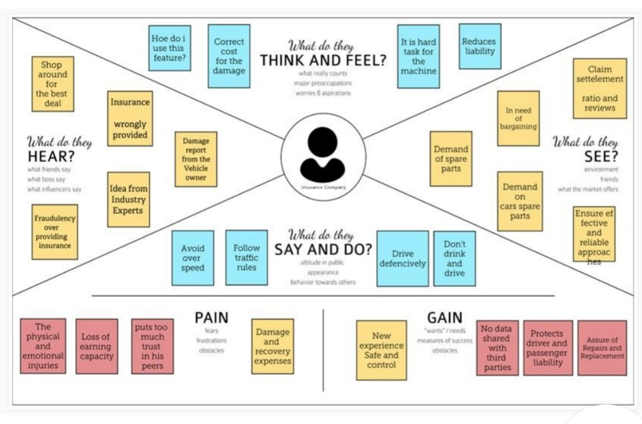

## b. Ideation & Brainstorming

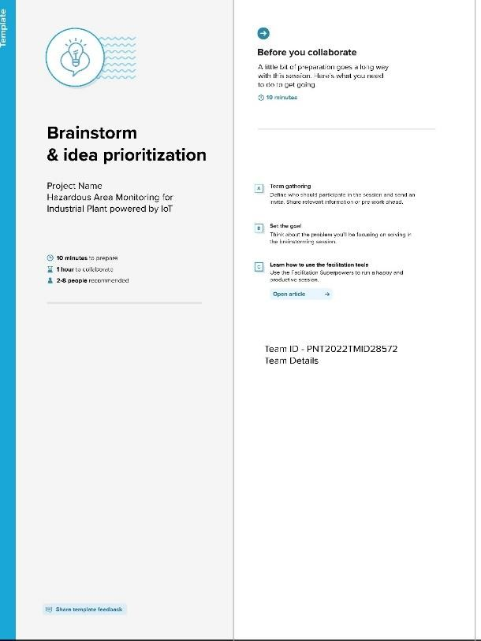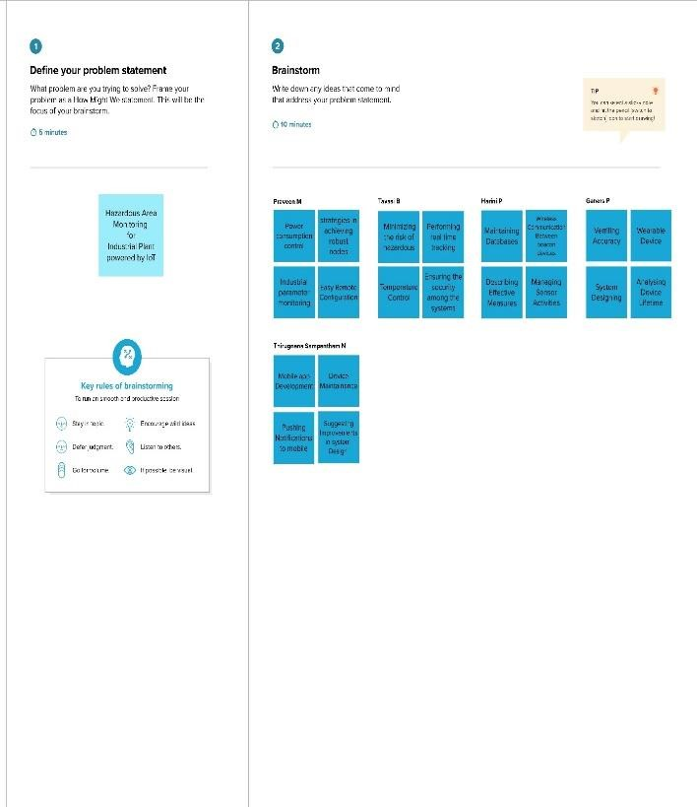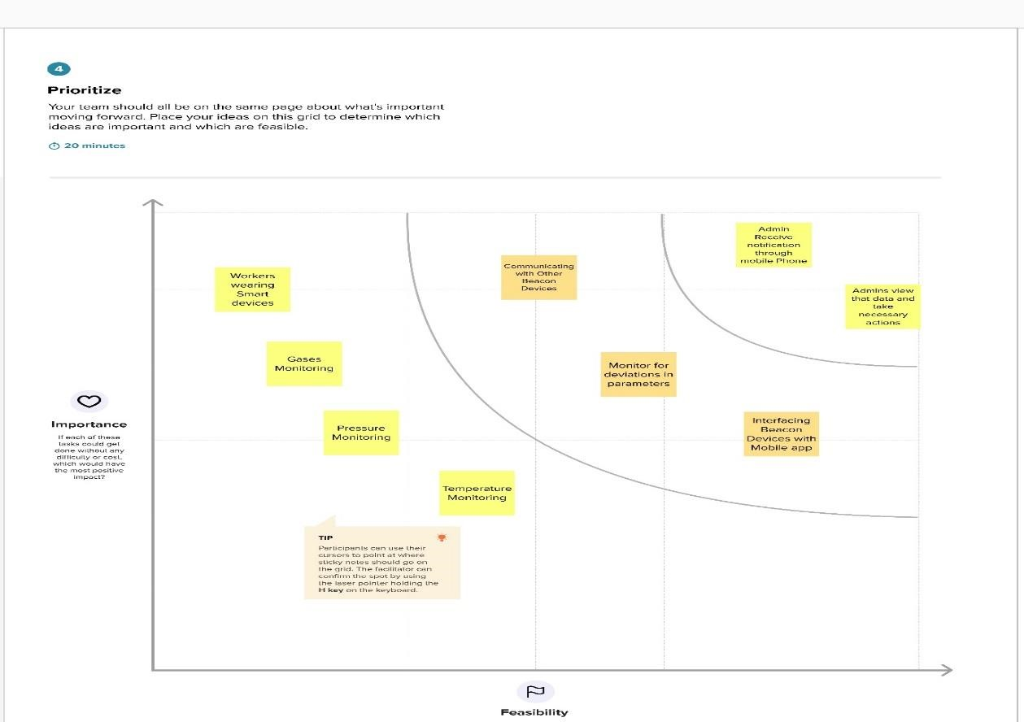

## c. Proposed Solution

|  |  |  |
| --- | --- | --- |
| **S. No** | **Parameter** | **Description** |
| 1. | Problem Statement (Problem to be solved) | Workers are the pillar of the company, while working in hazardous areas it is very difficult to avoid accidents, hence we need to ensure the safety of the workers. |
| 2. | Idea / Solution description | Hazardous Area Monitoring Industrial Plant powered by IoT, we are developing a system which will automatically monitor the industrial applications and generate Alerts/Alarms or make intelligent decisions using the concept of IoT. Every device will be acting as a beacon and it is connected to temperature sensors. An alert message is also sent to the mobile whenever high temperature (or) toxic gases are detected within the area through SMS using API. Through this wearable gadget, the information is sent to the cloud database and through which the dashboard, the admins of that specific plant can see the information and take fundamental activities on the off chance that required. |
| 3. | Novelty / Uniqueness | * Makes it easier to know the temperature (or) any hazardous gases present in the area without the worker having to constantly do manual checks. * Provides a different solution to ensure the safety of the workers. * Wearable devices display the current temperature present in the area all the time. • Alerts via SMS to mobiles of the workers when high temperature is detected. * Alerts on both the wearable device and mobile application occur simultaneously to prevent the worker from entering hazardous areas.   •These components are utilized to build a monitoring system. Apart from these components, several other sensors are used to keep a check on the temperature, gas leakage, pressure, humidity, etc. in the work environment to ensure the worker’s safety. |
| 4. | Social Impact / Customer Satisfaction | Due to a secure environment, labourers can work efficiently. More centre on work without any fear.     1. Real-time data is available 2. Reliable and consistent data 3. Automated detection   4)Excellent customer service  5)Ensures safety  6)Saves the lives of workers  7)Comfortable & User-friendly  8)Simple and reliable |
| 5. | Business Model (Revenue Model) | We can introduce a product-based approach to earn good revenue. And cost-effective So, Wearable devices can be priced and sold by the industry to the workers. |
| 6. | Scalability of the Solution | In some industrial plants, there are some areas which are to be monitored from time to time. To monitor the conditions, we can integrate the smart devices in the areas which are needed to be monitored. We use the IBM Watson cloud server to collect the live data and the current data. It ensures the safety of every worker working in harmful gases and high-temperature environment |

## d. Problem Solution fit

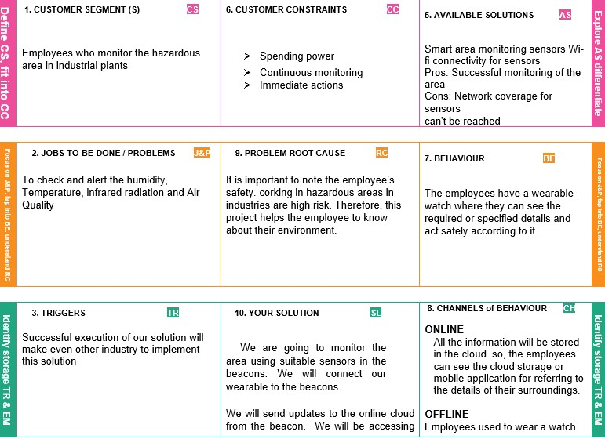

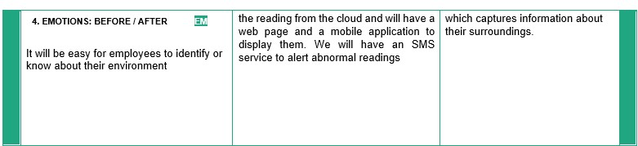

# 4. REQUIREMENT ANALYSIS

## a. Functional requirements

|  |  |  |
| --- | --- | --- |
| **FR No.** | **Functional Requirement (Epic)** | **Sub Requirement (Story / Sub-Task)** |
| FR-1 | User Registration | Registration through Form Registration through Gmail |
| FR-2 | User Confirmation | Confirmation via Email Confirmation via OTP |
| FR-3 | Cloud Registration | Registration through Gmail |
| FR-4 | Cloud Confirmation | Confirmation via OTP and Email |
| FR-5 | User Login | Login using credentials |
| FR-6 | User testing | Only verify any alert messages |
| FR-7 | User action | If there is any alert message, the admin alerts the workers |
| FR-8 | Authentication | Through OTP verification Through Strong passwords |
| FR-9 | Administration functions | Preventing and monitoring every second. If there is any deviation Admin sends a to workers. |

## b. Non-Functional requirements

|  |  |  |
| --- | --- | --- |
| **FR No.** | **Functional Requirement (Epic)** | **Sub Requirement (Story / Sub-Task)** |
| FR-1 | User Registration | Registration through Form Registration through Gmail |
| FR-2 | User Confirmation | Confirmation via Email Confirmation via OTP |
| FR-3 | Cloud Registration | Registration through Gmail |
| FR-4 | Cloud Confirmation | Confirmation via OTP and Email |
| FR-5 | User Login | Login using credentials |
| FR-6 | User testing | Only verify any alert messages |
| FR-7 | User action | If there is any alert message, the alert the workers |
| FR-8 | Authentication | Through OTP verification Through Strong passwords |
| FR-9 | Administration functions | Preventing and monitoring every second. If there is any deviation and send an alarm to workers. |

# 5. PROJECT DESIGN

## a. Data Flow Diagrams

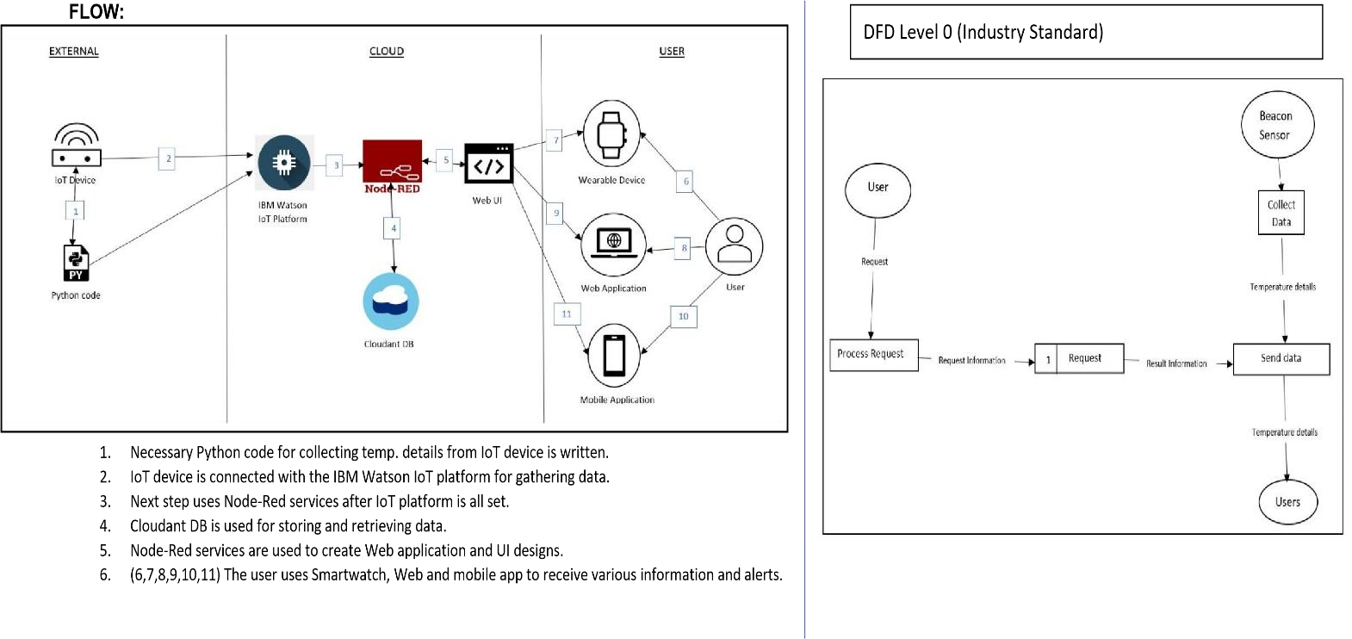

## b. Solution & Technical Architecture

**Solution Architecture:**

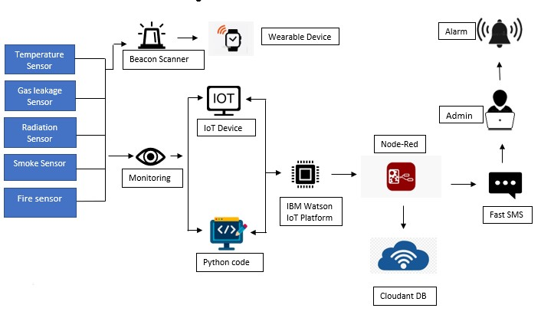

**Technical Architecture:**

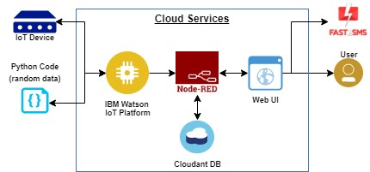

## c. User Stories

|  |  |  |  |  |  |  |
| --- | --- | --- | --- | --- | --- | --- |
| **User Type** | **Functional**  **Requirement** **(Epic)** | **User Story** Number | **User Story / Task** | **Acceptance criteria** | **Priority** | **Release** |
| Technician | Installation | USN-1 | The technician must install the smart beacons at points to ensure the entire area of the plant is covered. | A beacon can be found in every area of the plant. | High | Sprint-1 |
|  | Data Gathering | USN-2 | The beacons obtain the temperature of their respective area using sensors. | The temperature of areas within the plant is obtained. | High | Sprint-1 |
|  | Data Sync | USN-3 | The beacons send their data to the cloud in real time, which is sent to nearby wearable devices and the administrator’s dashboard. | Data is sent to the cloud successfully and synced with other devices. | High | Sprint-1 |
| Worker | Wearable  device display | USN-4 | The wearable devices should display the data sent by beacons within the area. | The user can see the temperature of the area on their device. | High | Sprint-1 |
|  | Wearable device adjustments | USN-5 | The user can adjust the size of the wearable device to better suit them. | The user can make  adjustments to the device to make working with it more comfortable. | Low | Sprint-2 |
|  | Wearable display customization | USN-6 | The user can adjust the device display to suit their needs on the device itself. | The user can modify the display of the device to increase readability. | Medium | Sprint-2 |
|  | SMS  Notifications | USN-7 | The user is sent a notification to their phone from the wearable device through an API when the area they are in | The user is informed of potential danger via  SMS as soon  as it is | High | Sprint-1 |
|  |  |  | reaches dangerous temperatures. | detected by the beacons. |  |  |
| Administrator | Admin  Dashboard | USN-8 | The beacons send the data through the  cloud to a dashboard which is run by the administrator. | The data of all the beacons can be viewed by the  administrator of the plant. | High | Sprint-1 |
|  | Dashboard  Customization | USN-9 | The dashboard  can be customized by the admin to suit their  requirements and priorities. | The admin can customize the UI for their dashboard. | Mediu m | Sprint-2 |

# 6. PROJECT PLANNING & SCHEDULING

## a. Sprint Planning & Estimation

|  |  |  |  |  |  |  |
| --- | --- | --- | --- | --- | --- | --- |
| **Sprint** | **Functional Requirem**  **ent (Epic)** | **User**  **Story**  **Number** | **User Story / Task** | **Story Points** | **Priority** | **Team**  **Members** |
| Sprint-1 | Simulati on Creation | USN-1 | Conne  ct  sensor  s,  Arduin o and esp82  66 | 2 | High | Dinesh,Arunkumar |
| Sprint-1 | Software | USN-2 | Develop an application with MIT App inventor  (Login page with firebase) | 2 | High | Dinesh, Sivakumar, Karthik |
| Sprint-2 | Software and Hardware | USN-3 | Connect the hardware with IBM Cloud and  API Integration | 2 | Medium | Karthik,Dinesh,Manoj |
| Sprint-2 | Software | USN-4 | Application development for the project | 2 | High | Dinesh,  Manoj,  Karthik |
| Sprint-3 | Software | USN-5 | Establishing  Node-Red | 2 | Medium | Dinesh, Arunkumar |
|  |  |  | connection |  |  | Karthik,Manoj,Dinesh |
| Sprint-3 | Software | USN-6 | Connecting applications with Node-Red and further application development | 2 | High | Dinesh, Sivakumar, Karthik |
| Sprint-4 | Testing | USN-7 | Testing developed application and working model of hardware | 2 | High | Karthik,Dinesh,Manoj |

## b. Sprint Delivery Schedule

|  |  |  |  |  |  |  |
| --- | --- | --- | --- | --- | --- | --- |
| **Sprint** | **Total Story Points** | **Duration** | **Sprint**  **Start Date** | **Spri nt**  **End**  **Date (Pla nne**  **d)** | **Story Points**  **Completed**  **(as on**  **Planned End**  **Date)** | **Sprint**  **Release Date**  **(Actual)** |
| Sprint-1 | 16 | 6 Days | 24 Oct 2022 | 29 Oct  2022 |  | 30 Oct 2022 |
| Sprint-2 | 16 | 7 Days | 31 Oct 2022 | 06 Nov  2022 |  | 07 Nov 2022 |
| Sprint-3 | 16 | 6 Days | 09 Nov 2022 | 13 Nov  2022 |  | 14 Nov 2022 |
| Sprint-4 | 8 | 6 Days | 15 Nov 2022 | 17 Nov  2022 |  | 1. Nov 2022 – 2. Nov   2022 |

# 7. CODING & SOLUTION

Language: Python.

Tools/IDLE: Python 3.9.6, IBM Watson IoT platform, Node-RED, E-mail, Cloudant DB.

#Connecting the python to IBM Watson IoT platform

import wiotp.sdk.device import time

import random

myconfig = {

"identity":{

"orgId":"ph99dh",

"typeId":"NodeMCU ",

"deviceId":"123456"

},

"auth":{

"token":"gkfpv_xfl1FB1)*fvy”

}

}

def myCommandCallback(cmd): print("Message received from IBM IoT platform: %s" % cmd.data['command']) m=cmd.data['command']

client = wiotp.sdk.device.DeviceClient(config=myconfig, logHandlers=None) client.connect()

while True:

temp=random.randint(-20,125) hum=random.randint(0,100)

myData = {'temperature’: temp, 'humidity’: hum}

client.publishEvent(eventId="status", msgFormat="json”, data=myData, qos=0, onPublish=None) print("Published data Successfully: %s”, myData) client.commandCallback =myCommandCallback time.sleep(2)

client.disconnect()

# 8. TESTING

## a. Test Cases

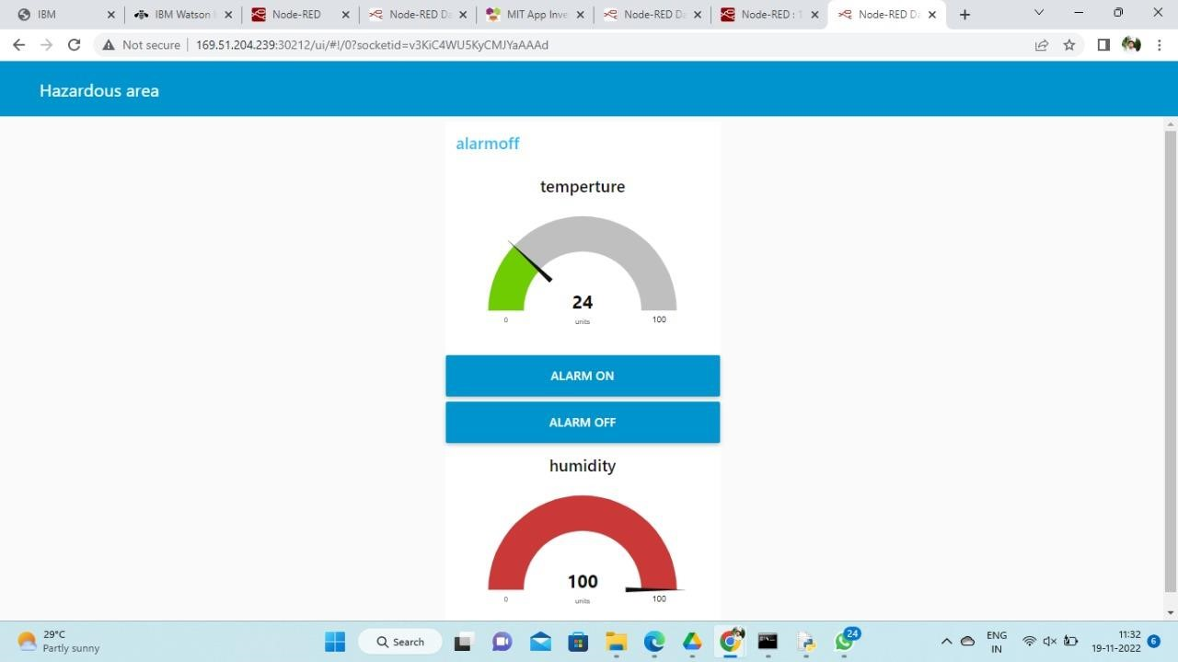

## b. User Acceptance Testing

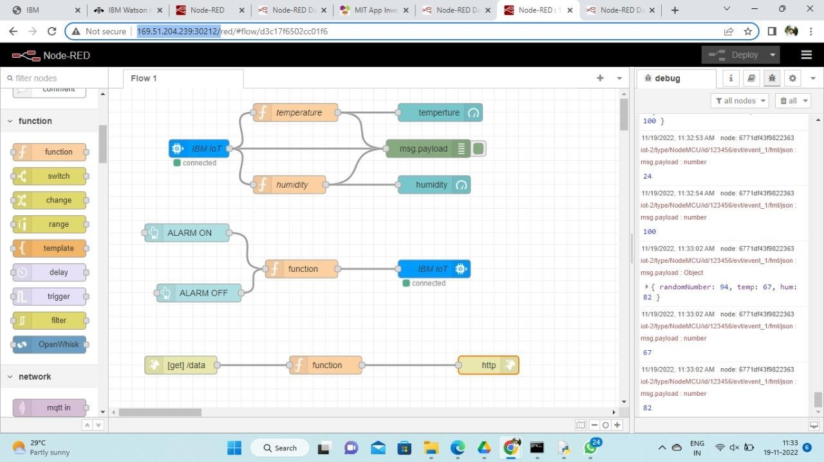

# 9. RESULTS

## a. Performance Metrics

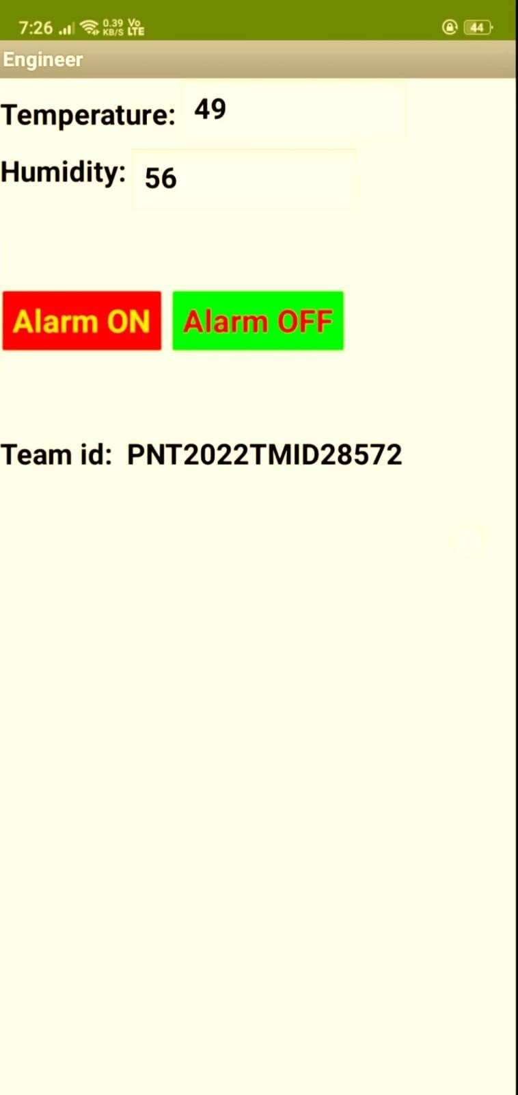

# 10. ADVANTAGES & DISADVANTAGES

### ADVANTAGES

* Quickly Finding Any Issue in Production Line.
* Keeping Records of Raw Materials & Accuracy.
* Predict what problem might occur.
* Decrease the deaths in Accidents.
* Ensuring safety and comfort.
* No Need for Routine Survey.

### DISADVANTAGES

* Misuse of privacy and data.
* Expense.
* Communication channel disconnection occurs often.
* Complex uses.

# 11. CONCLUSION

The Internet of Things offers a large scope for influencing the world of the future. The IoT system has several drawbacks, but these are outweighed by its benefits, such as saving consumers time and money. IoT applications are expected to soon be installed and utilized equally in household and commercial and business districts. Businesses are putting a lot of effort into combating IoT drawbacks and improving this cutting-edge technology for the benefit of humanity.

# 12. FUTURE SCOPE

Future IoT technologies will undoubtedly be successful, and IoT-enabled gadgets will probably be found everywhere, from businesses to homes. IoT has a bright and diverse future, and it won't be long until the aforementioned uses of the technology become a reality.

While real-time self-monitoring of a patient's health is made possible by wearable technology, the sensors and variations employed in the healthcare sector are substantially more advanced. The proportion of manual errors in taking medical readings will decrease as sensors' accuracy and precision based on IoT grow.

# 13. APPENDIX

## a. Source code

import wiotp.sdk.device import time

import random

myconfig = {

"identity":{

"orgId":"ph99dh",

"typeId":"NodeMCU ",

"deviceId":"123456"

},

"auth":{

"token":"gkfpv_xfl1FB1)*fvy”

}

}

def myCommandCallback(cmd):

print("Message received from IBM IoT platform: %s" % cmd.data['command']) m=cmd.data['command']

client = wiotp.sdk.device.DeviceClient(config=myconfig, logHandlers=None) client.connect()

while True:

temp=random.randint(-20,125) hum=random.randint(0,100)

myData = {'temperature’: temp, 'humidity’: hum}

client.publishEvent(eventId="status", msgFormat="json”, data=myData, qos=0, onPublish=None)

print("Published data Successfully: %s”, myData) client.commandCallback =myCommandCallback time.sleep(2)

client.disconnect()

## b. Video demonstration links

**Demo Link:**

https://youtu.be/-b9NPIjsoag